Brigadier General Stephen A. Cheney, USMC (Ret.)
Delegation Leader; CEO, ASP

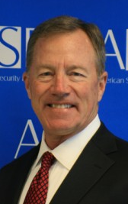
BGen Stephen Cheney USMC (Ret.) is the Chief Executive Officer of the American Security Project (ASP) and a member of the Department of State’s Foreign Affairs Policy Board. He is a graduate of the U.S. Naval Academy and has over 30 years’ experience as a Marine. His career included a wide variety of command and staff positions with the operating forces and the supporting establishment. He served several years in Japan and has traveled extensively throughout the Middle East and Asia. Other selected highlights of his military career include tours as Deputy Executive Secretary to Defense Secretaries Cheney and Aspin; ground plans officer for Drug Enforcement Policy in the Pentagon; liaison to the Congressional Commission on Roles and Missions of the Armed Forces; and Inspector General of the Marine Corps. Following retirement from the Marines, he became the Chief Operating Officer for Business Executives for National Security (BENS), in Washington, D.C., and most recently was President/CEO of the Marine Military Academy in Harlingen, Texas. He was a military fellow at the Council on Foreign Relations in New York City, where he is a member. He is also a member of the Secretary of State’s International Security Advisory Board. He has been on the Board of Directors for ASP since 2006.

Vice Admiral Lee Gunn, USN (Ret.) (ASP Board Member)
President of the Institute for Research, CNN

Vice Admiral Lee Gunn served in the U.S. Navy for thirty-five years prior to his retirement in 2000. His last active duty assignment was Inspector General of the Department of the Navy where, together with his Marine Deputy, he was responsible for the Department’s overall inspection program and its assessments of readiness, training, and quality of service. Serving in the Surface Navy in a variety of theaters, Admiral Gunn rose through the cruiser/destroyer force to command the Frigate USS Barbey, then command of the Navy’s anti-submarine warfare tactical and technical evaluation Destroyer squadron, DESRON 31. He later commanded Amphibious Group Three, comprising 19 ships, 12 other, separate commands, and 16,000 Sailors and Marines. As Commander of PHIBGRU THREE he served (in addition to many other duties) as the Combined Naval Forces Commander, and Deputy Task Force Commander of Combined Task Force United Shield. Task Force United Shield conducted the final withdrawal of United Nations peacekeeping forces from Somalia in February and March of 1995. United Shield was, and still is, the only amphibious withdrawal operation under fire conducted since the Korean War. Admiral Gunn’s awards include the Distinguished Service Medal, the Defense Superior Service Medal, six Legions of Merit, two Meritorious Service Medals, the Navy Commendation Medal (with Combat Distinguishing Device), the Navy Achievement Medal, the Combat Action Ribbon, and numerous theater and service awards. Immediately after concluding his active duty career, Admiral Gunn was asked by the Chief of Naval Operations to lead the Executive Review of Navy Training. The nine-month Review was conducted by a senior team of experts in a variety of disciplines from the uniformed Navy, the corps of Department of the Navy Civilians, and the business and education communities. The recommendations of the Review continue to be implemented by the Navy, bringing about a revolution in training and learning for Navy men and women. Admiral Gunn has extensive experience with and substantial accomplishments in the areas of manpower, personnel and training. He served in eight assignments in those areas during his career. During his last manpower assignment (as Deputy Chief of Naval Personnel, and Commander, Navy Personnel Command) he played a key role in redesigning the Navy’s manpower and personnel establishment and orchestrated the transfer of the Navy’s Personnel Command from Arlington, Virginia to Millington, Tennessee. Relations he developed with the Congressional delegations and the business and academic communities were key to the success of this BRAC–directed move. Gunn serves as: President of the Institute for Public Research at CNA in Alexandria, VA. (he joined CNA in 2001); Chair of the Board of Advisors of the Naval Postgraduate School in Monterey, CA; an Advisor to the Global Perspectives Initiative at the University of Central Florida; and a member and Executive Board member of the Surface Navy Association, the professional association of more than 7000 surface warriors and supporters. He served as President of the Surface Navy Association from 2001-2006. Admiral Gunn holds a Bachelor’s degree in Experimental and Physiological Psychology from the University of California, Los Angeles and a Master of Science degree in Operations Research from the Naval Postgraduate School in Monterey, California.

Lt. General John Castellaw, USMC (Ret.) (ASP Board Member)
CEO, Farmspace Systems
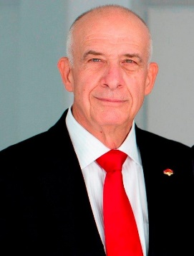
John “Glad” Castellaw is the chief executive officer (CEO) of Farmspace Systems a provider of precision agriculture services and equipment in the Mid-South. Castellaw graduated from the University of Tennessee, Martin (UTM) in 1972 with a commission in the Marines and a degree in Agriculture. For 36 years he led Marines around the world while flying more than two dozen different types of aircraft. Castellaw served with the UN during the Siege of Sarajevo, commanded the American force in the multi-national security and stability operation in East Timor, and as the chief of staff for the U.S. Central Command at the height of the war in Iraq. His last tours were in the Pentagon where he oversaw Marine Aviation and then the Marine Corps budget. In 2008, he returned to Tennessee where he operates the family farm, is a teaching fellow at UTM, and on the board of the Bank of Crockett. Castellaw is the president of the non-profit Crockett Policy Institute and is a senior associate with the Washington based Corvus Group. Other national security affiliations include membership on the Nuclear Security Working Group, the Climate Security Working Group, and the board of the American Security Project. As a retired service member, Castellaw maintains a deep interest in National Security issues and in veterans’ affairs. He participates actively with various groups working to ensure this nation’s defense needs are met and serves on the Department of the Navy’s Naval Research Advisory Committee. As a veteran, he is a member of the Marine Corps League, The Marine Corps Association, and The Naval Institute and is beginning his first term as the National Commander of the Marine Corps Aviation Association.

Maj. General Paul D. Eaton (ASP Consensus Member)

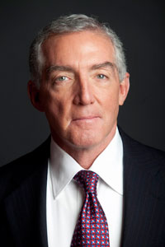
Since retirement from the US Army in 2006 after 33 years service, Major General Paul D. Eaton has actively engaged in the recent Presidential campaign and currently serves as Senior Advisor to the National Security Network. His Army assignments include Infantry command from the company to brigade levels and command of the Infantry Center at Fort Benning and Chief of Infantry. His most recent operational assignment was Commanding General of the command charged with reestablishing Iraqi Security Forces 2003-2004, where he built the command and established the structure and infrastructure for the Iraqi Armed Forces and Interior Ministry security forces. Other operational assignments include Somalia, Bosnia and Albania. Other assignments include the Joint Staff, Deputy Commanding General for Transformation and Stryker Unit Development and Assistant Professor and head of the French Department at West Point. He is a 1972 graduate of West Point, married to PJ Eaton and father to sons Shane and Joshua, and daughter Gina, all Soldiers.

Brigadier General Stephen Xenakis, USA (Ret.) (ASP Consensus Member)

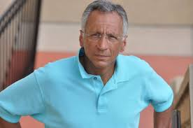

Dr. Stephen Xenakis is a retired brigadier general and Army medical corps officer with 28 years of active service. He is an adjunct clinical professor at the Uniformed Services University of Health Sciences. He is the Founder of the Center for Translational Medicine, a nonprofit that conducts clinical research and development. He has been a senior adviser to the Department of Defense on neurobehavioral conditions and medical management. Dr. Xenakis serves as an anti-torture advisor to Physicians for Human Rights and belongs to the group of retired generals and admirals convened by Human Rights First. His clinical practice has been broad and varied over the past 40 years, including expert consultation to military attorneys and providing inpatient care, substance abuse and alcohol treatment, and community health services. Dr. Xenakis serves on the Executive board of the Center for Ethics and Rule of Law.

Brigadier General Dave McGinnis, US Army (Ret.)
Retired
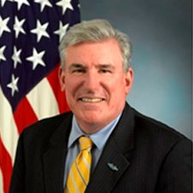
BG Dave McGinnis was the Chief of Staff of the National Guard Association of the U.S. McGinnis served as director of strategic plans and analysis in the office of the Assistant Secretary of Defense for Reserve Affairs. He served two tours in Vietnam before leaving the active Army in 1972 to join the New York National Guard. In 1990, he rose to branch chief of the force management division at National Guard Bureau (NGB) in Washington. Subsequent assignments included Deputy Chief from 1991-92 and Director from 1992-1993. He is a graduate of the State University of New York and later earned an advanced degree from the Army War College in 1991. Nicholas Clark (ASP Board Member)
CEO and Executive Director of Alexium International; ASP Board Member
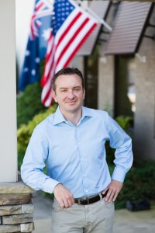
Nicholas Clark has over two decades of experience in business and is the CEO and Executive Director of Alexium International, an innovative chemical solutions company serving the military and commercial sectors.
A successful entrepreneur, Nicholas is also co-founder and Managing Partner at Viaticus Capital. He has established several successful firms and worked for a number of years in investment banking, principally in M&A. Nicholas has lived and worked in Beijing, China, and throughout Southeast Asia. Whilst in China, he was responsible for acquisitions in excess of a billion dollars, and successfully established a commercial and contractual position for a $12.5 billion major mining construction program for the Chinese. Prior to starting his business career, Nicholas served in the Australian Army with the Australian Defense Force and received military commendations for service as peace keeper with the U.N. In addition to having credentials in Economics and Law, Nicholas has also earned a Master of Business Administration and a Ph.D. having attended Sydney University, Columbia and Yale. Nicholas was invited to participate for two years at the prestigious Yale CEO college. He has published a number of critical thinking articles in the field of business, leadership and management, as well as social and political subjects. His scholarly work includes: Is Business Economics Complicating our Work?;Managing and Leading “There is a difference”; The Practical Leader “Yes it’s common sense”; Communicate “Damn it”; Leading Teams to Effective Results; The Critical Analyses of the Current State of Global Economies; Merger and Acquisitions Creating Value Not Losses; Strategy Formulation and Articulation; and How and when to decide.

Andrew Holland
Director of Studies and Senior Fellow for Energy and Climate, ASP
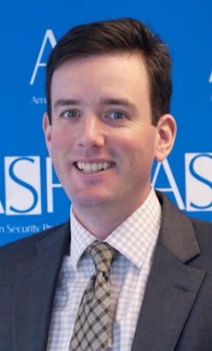
Andrew Holland is the American Security Project’s Director of Studies and Senior Fellow for Energy and Climate. As an expert on energy, climate change, and infrastructure policy, he has worked at the center of debates about how to achieve sustainable energy security and how to effectively address climate change for the last decade. He served as Legislative Assistant on Energy, Environment, and Infrastructure for United States Senator Chuck Hagel of Nebraska for three years from 2006 through 2008. He worked in the US House of Representatives for the House Ways and Means Committee and the Office of Congresswoman Roukema. He holds a Master’s Degree in International Strategy and Economics from the University of St. Andrews in Scotland and a Bachelor’s Degree in History and Economics from Wake Forest University in North Carolina. He is originally from New York City, grew up in New Jersey, and currently resides in Alexandria, VA.

Maggie Feldman-Piltch
Special Advisor to the CEO and Board of Directors, ASP
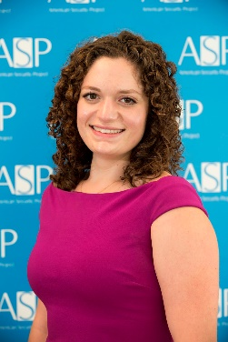
Maggie Feldman-Piltch is the Special Assistant to the CEO and Board of Directors at American Security Project where she provides strategic and operational assistance to the CEO and Board of Directors, oversees special projects, and leads the organization’s private sector stakeholder engagement. She also leads ASP’s Women in Security Leadership Initiative (WiSe) and is the host of ASP’s weekly podcast series “What’s Next?”
Prior to joining ASP, Maggie worked for The Conference Board in the Research Working Groups department and served as an Advanced Risk Apprentice with Risk Cooperative after spending time working the fashion and consumer goods industries. She is a graduate with honors of Wesleyan University and a Master’s candidate at Georgetown’s School of Foreign Service in the Security Studies Program. She is also pursuing in Advanced Diploma in Opera Performance from the Royal Academy of Music through a joint program with the Levine School of Washington, D.C.
Maggie is the founder of the WiSelist, an international network and mentoring program for women in foreign policy and security related fields. She is a contributor to Teen Vogue on women in politics and policy, and a classically trained coloratura soprano under the direction of Joyce Lundy and The West Wing aficionado.

